Can bundled deals increase market share?

Vincent D Taylor

Western Governors University

D205 Data Acquisition

Abstract

For my research question I wanted to know “If there was any correlation between customers owning tablets and having Fiber Optic Internet?” Bundle deals are a common strategy businesses use in order to increase market share in a given industry. Taking an approach like this would allow us to potentially capture more of the premium Fiber Optic markets. We could further expand this query to target our other offerings such as mobile, online security, online backup and tech support which could capture market share in the rest of these valuable markets.

### A1) What Data is needed?

In order to identify our target market, we will need to know the of total number of customers who utilize our internet service column from the add-on “services” csv file. We will also need to get the number of how many customers own a tablet, which is going to be found on the customer table under the “tablet” column. Finally in order to join these two fields together we will utilize the “customer_id” field in order to see if a relationship exists between each type of internet service and if a customer owns a tablet. For all of the data I need the data type will be text.

### B1) ERD Relationship

### 

### B1) Creating the Add-on Table

In order to create the add-on table, I first created the columns using SQL code. After running the code, I verified the output to ensure that the correct columns were loaded.

|  |
| --- |
| CREATE TABLE services (  customer_id TEXT NOT NULL,  "InternetService" TEXT NOT NULL,  "Phone" TEXT NOT NULL,  "Multiple" TEXT NOT NULL,  "OnlineSecurity" TEXT NOT NULL,  "OnlineBackup" TEXT NOT NULL,  "DeviceProtection" TEXT NOT NULL,  "TechSupport" TEXT NOT NULL,  PRIMARY KEY (customer_id),  FOREIGN KEY (customer_id) REFERENCES public.customer(customer_id)  );  ALTER TABLE services  OWNER TO postgres; |

### B2) Loading CSV using SQL code

Once the headers were created, I used another code in order to add the data to the services file.

|  |
| --- |
| COPY services  FROM 'C:\LabFiles\services.csv'  DELIMITER ','  CSV HEADER; |

### C) Research Query Code

|  |
| --- |
| SELECT  COUNT(customer_id) AS total,  tablet  FROM customer  GROUP BY tablet  ORDER BY tablet;  SELECT  customer.tablet AS total_tablet,  services."InternetService" AS internet_type,  COUNT(customer.customer_id) AS total_customers  FROM customer AS customer  INNER JOIN services AS services  ON customer.customer_id = services.customer_id  GROUP BY customer.tablet, services."InternetService"  ORDER BY customer.tablet, services."InternetService";CSV HEADER; |

### C1) Research Query Output

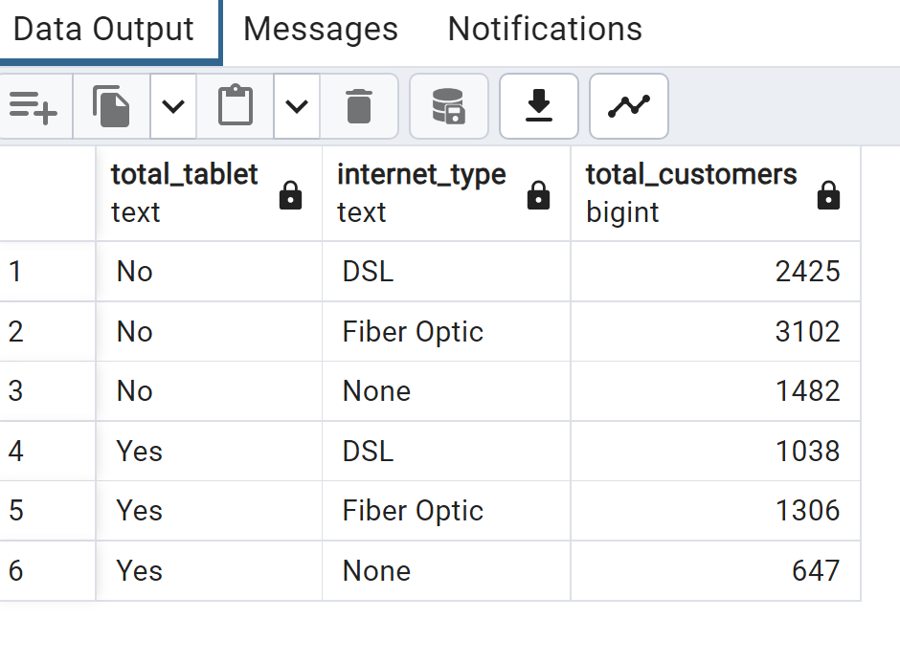

### D) How often should data be refreshed?

Based on the research question I believe once the bundle deal for fiber optic has been reviewed and approved it should be updated quarterly. This time period is important because companies report earnings to key stakeholders both internally and externally quarterly. Furthermore, by updating the data quarterly, we will be able to measure the profitability that is related to the tablet/ fiber optic bundle deal. We would also be able to communicate the effectiveness of the program and allow stakeholders to determine if this should be rolled out across any other lines of business. Below is the script we would run to update the table with new data.

### D) Refreshing add-on table

It will be important to update the table quarterly to ensure that we always have the latest information to review the bundle package deal to ensure we have the most up to date information. Below is the code to refresh the table with updated data.

|  |
| --- |
| DROP TABLE IF EXISTS services  CASCADE;  COPY services  FROM 'C:\LabFiles\services.csv'  DELIMITER ','  CSV HEADER; |

References

PostgreSQL Cheat Sheet - Download the Cheat Sheet in PDF Format. (n.d.). Retrieved October 11, 2023, from <https://www.postgresqltutorial.com/postgresql-cheat-sheet/>